* **Bao gồm 2 class**
  + 1 annotation interface
  + và 1 validator class
* **Annotation interface**
  + **@Target**

Nơi Annotation được sử dụng

* + **@Retention**
  + **@Constraint**

Đánh dấu Constraint là 1 Bean Validation constraint

**validatedBy**: chỉ ra class validator (class implement constraint)

* + **@interface**: định nghĩa Annotation
  + **Attribute bên trong @interface**
    - **String message**

Định nghĩa message sẽ show ra khi data không hợp lệ

* + - **Class<?>[] groups()**

Chỉ định group cho Annotation (xem Group Constraint)

VD: @Age(groups=MALE).

* + - **long value**

attribute property để get data

VD: @Age(value=18).

* + - **Class<? extends PayLoad> []payLoad()**

Payloads are typically used to carry metadata information consumed by a validation client

* + - **@interface List**

Validation trên List

|  |  |
| --- | --- |
|  |  |
| ***@Target*** | ***@Retention*** |

* **Validator class**
  + **initialize()**

get data & init value

* + **isValid()**

Check data

* **VD1: Field, List, Parameter validator**

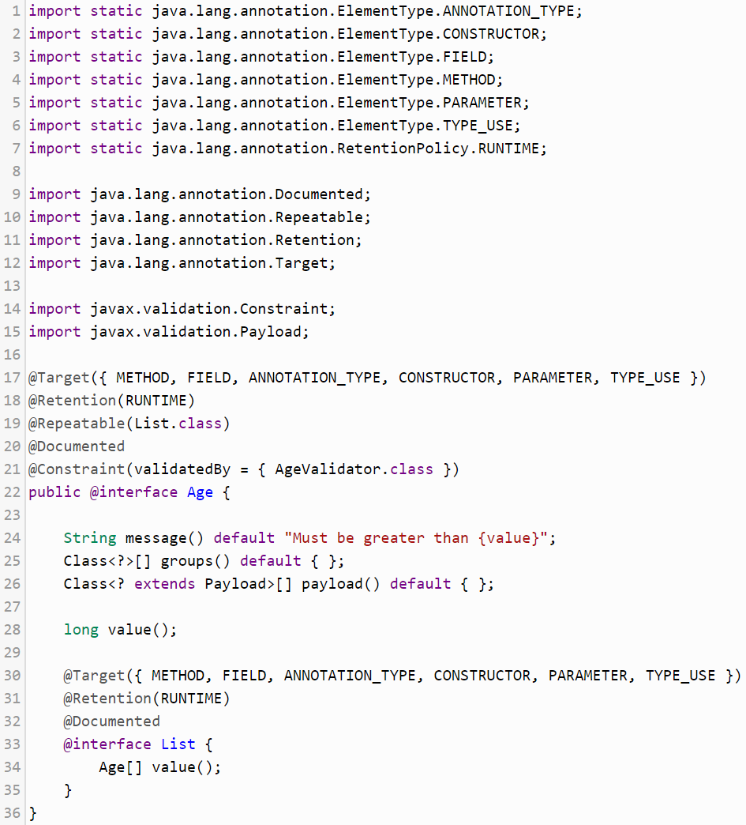

*Annotation interface*

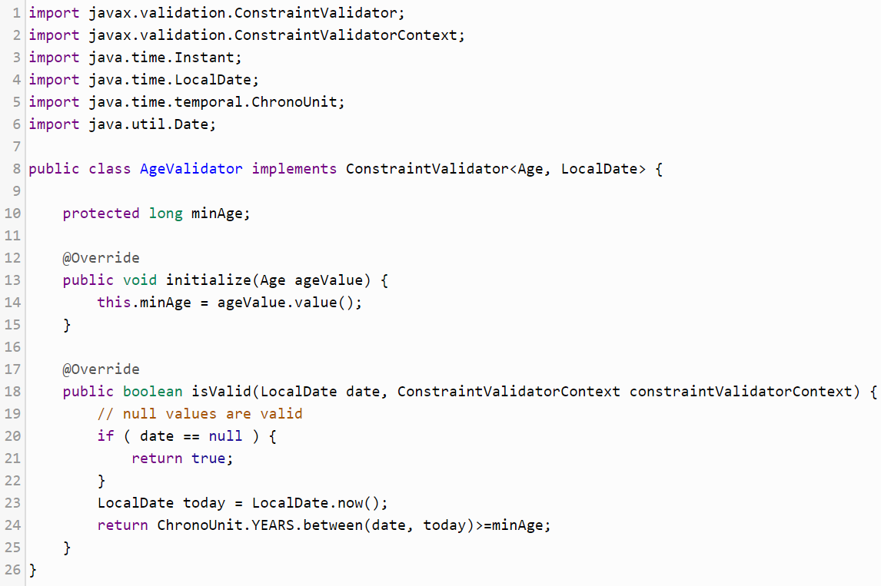

*Validator class*

**

*Using*

[*https://dzone.com/articles/create-your-own-constraint-with-bean-validation-20*](https://dzone.com/articles/create-your-own-constraint-with-bean-validation-20)

* **VD2:** **method, constructor validator**

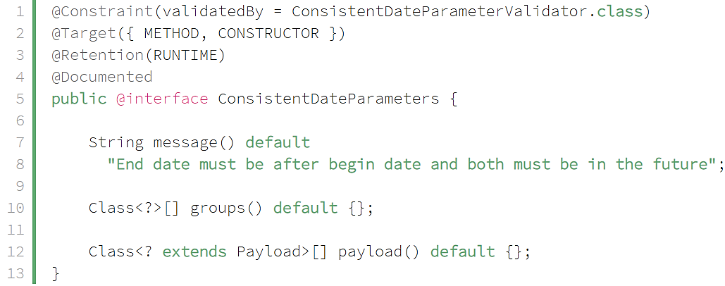

*Annotation interface*

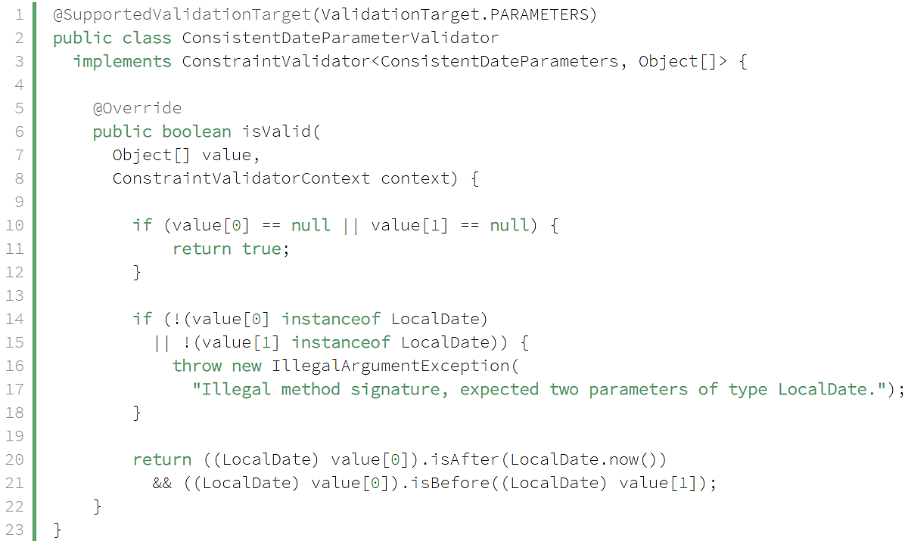

*Validator class*

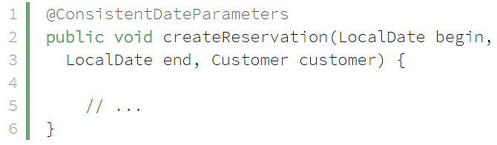

*Using*

* VD3: **return object Validator**

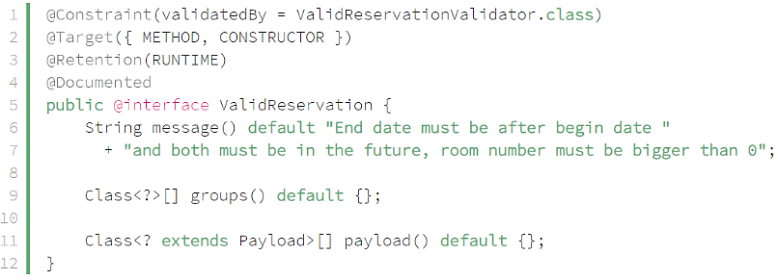

*Annotation interface*

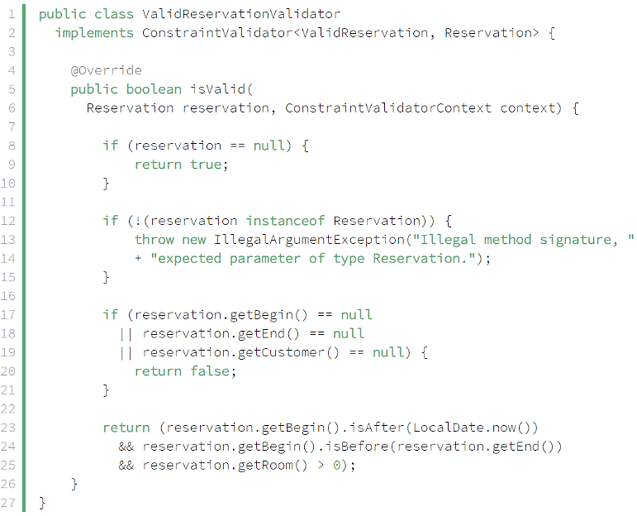

*Validator class*

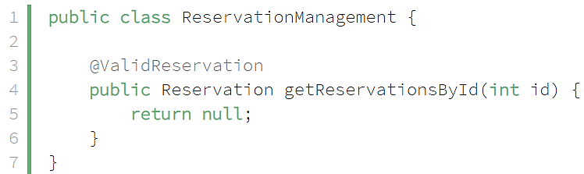 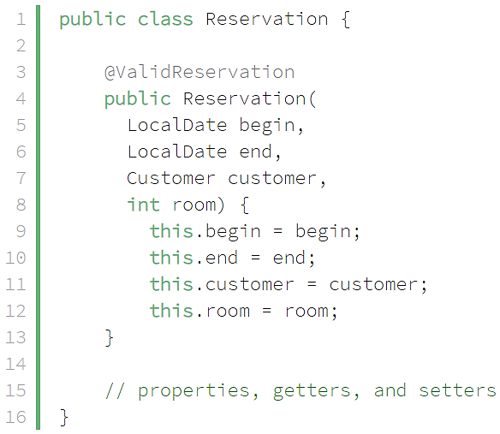

*Using (sử dụng method hoặc constructor)*

* **Custom default message in isValid() method**

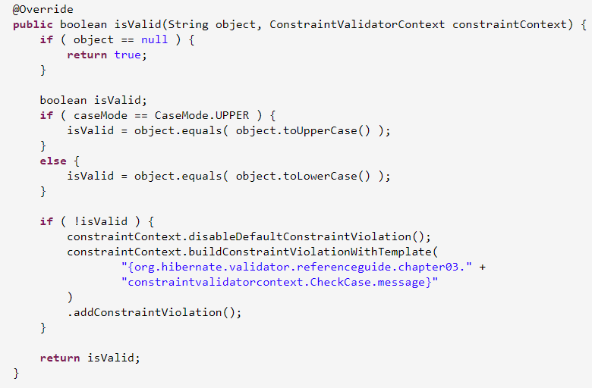

<https://docs.jboss.org/hibernate/validator/5.0/reference/en-US/html/validator-customconstraints.html#validator-customconstraints-validator>

* **Validate multiple field**

<https://in.relation.to/2008/04/01/bean-validation-sneak-peek-part-ii-custom-constraints/#H-ClasslevelConstraints>

* **Reference**

<https://dzone.com/articles/create-your-own-constraint-with-bean-validation-20>

<https://www.baeldung.com/javax-validation-method-constraints>

<https://docs.jboss.org/hibernate/stable/validator/reference/en-US/html_single/#validator-customconstraints-simple>